





# -iIters









<LOD EXCLL/0E>



## Ch¥›•s









esrJude Sales subceteeeey 11'4,880 741000



91,705 742.000



107,V2 7l$,Q47

# 27.1t9 7U.047



203,4L8 7B047

N,#76 7I9,Og7

3024 7J90u7



46.674 7U.047

# 330.007 JS4

Dashboard Słory Analysis Map Format Server Wirldow Hetp

@ d' Standard • g@ • @ @

' Page•



Sheetl9



mer Name

     



 

:saIes in different states>

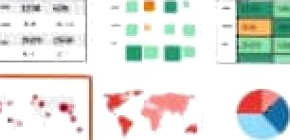

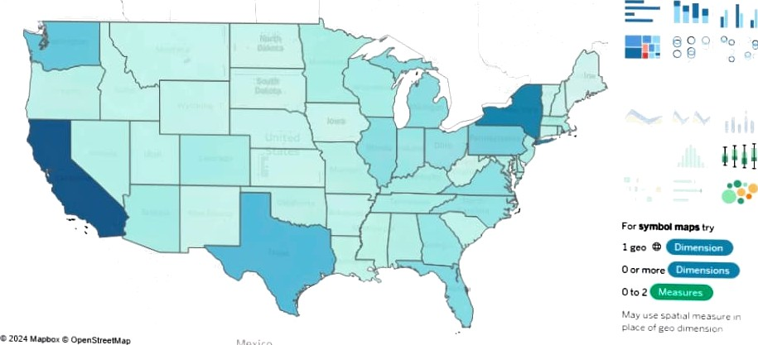I •











” ‹LOO EXCLUDE>







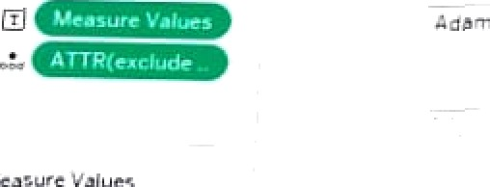



@ Standard • 



*14 742.000 74£.000

72.000





742,000

7g20OO

71.000



 

in $toş Analysis slap I-ormat Serve window Help

## El • z # Stan‹b‹d łQ • Q @

a Rows

# Sheet20



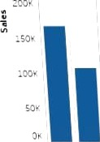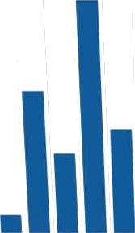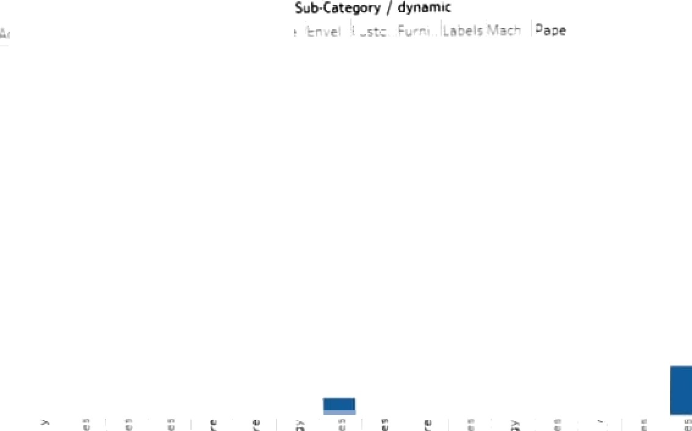

boat Story Analysis ktap format Serve Window Help



*"



Profit in different states

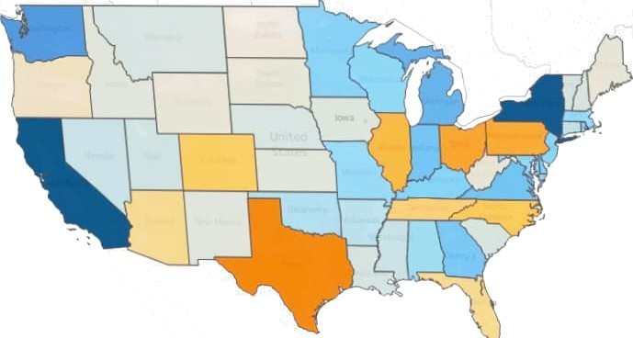



For cymbot maps \‹y

